Time Adjunct

✅ What Is a Time Adjunct?
# Source: AI Source: Provided by: [Data Path: Persons Table -> ID Column: 1, Name_En Column: Motasem Essam] -> From: [Chatgpt (GPT-4-turbo)] on [8/5/2025]
A time adjunct is a word, phrase, or clause that provides non-essential information about when an action or event takes place. It answers questions like:
- When?
- How long?
- How often?
It is a type of adverbial adjunct and can be placed at the beginning, middle, or end of a sentence.

🔸 Common Forms of Time Adjuncts:
# Source: AI Source: Provided by: [Data Path: Persons Table -> ID Column: 1, Name_En Column: Motasem Essam] -> From: [Chatgpt (GPT-4-turbo)] on [8/5/2025]
- Adverbs: today, yesterday, soon, lately, always, never
- Prepositional Phrases: in the morning, at night, during the summer
- Noun Phrases: last year, this week
- Clauses: when she arrived, after he left

🔸 Examples of Time Adjuncts in Sentences:
# Source: AI Source: Provided by: [Data Path: Persons Table -> ID Column: 1, Name_En Column: Motasem Essam] -> From: [Chatgpt (GPT-4-turbo)] on [8/5/2025]
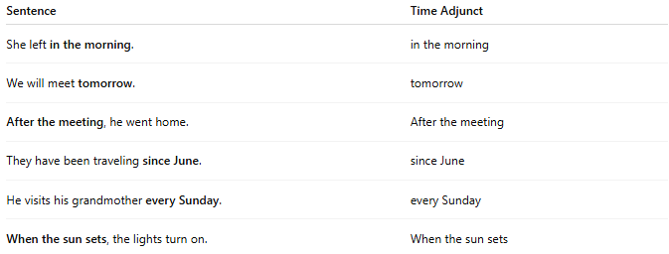
Sentence | Time Adjunct
She left in the morning. | in the morning
We will meet tomorrow. | tomorrow
After the meeting, he went home. | After the meeting
They have been traveling since June. | since June
He visits his grandmother every Sunday. | every Sunday
When the sun sets, the lights turn on. | When the sun sets

🔸 Position in the Sentence:
# Source: AI Source: Provided by: [Data Path: Persons Table -> ID Column: 1, Name_En Column: Motasem Essam] -> From: [Chatgpt (GPT-4-turbo)] on [8/5/2025]
- Initial: After dinner, we watched a movie.
- Medial: She has often visited us.
- Final: He will call you in the evening.

🔸 Reminder:
# Source: AI Source: Provided by: [Data Path: Persons Table -> ID Column: 1, Name_En Column: Motasem Essam] -> From: [Chatgpt (GPT-4-turbo)] on [8/5/2025]
A time adjunct is optional — it adds information, but the sentence remains grammatical without it.
🟢 "She left."
🟡 "She left in the morning." → Time adjunct added for detail

